**FORMATS FOR IMPLEMENTACION PROCESS IMPROVEMENT**

Table 3.1 Generic Goals, Generic Practices, and Related Process Areas

|  |  |
| --- | --- |
| Generic Goal and Generic Practice | Related Process Area |
| Generic Goal 1: Achleve Specific Goals Each Process Area |  |
| Generic Goal 1.1: Perfonrm Specific Practices of the Process Areas | Specific practices of one or more Process Areas, depending on the extent of the model to be archived |
| Generic Goal 1.1: Institutionalize a Managed Process | Specific practices of one or more Process Areas, depending on the extent of the model to be archived |
| Generic Goal2: Institutionalize a Managed Process |  |
| GP2.1: Establish an Organizational Policy | Project Planning |
| GP2.2: Plan the Process | Project Planning |
| GP2.3: Provide Resources | Project Planning |
| GP2.4: Assign Responsibility | Project Planning |
| GP2.5: Train People | Organizational Training  Project Planning |
| GP2.6: Mange Configurations | Configuration Management |
| GP2.7: Identify and Involve Relevant Stakeholders | Project Planning  Project Monitoring and Control  Integrated Project Management (with IPPD) |
| GP2.8: Monitor and Control the Process | Project Monitoring and Control  Measurement and Analysis |
| GP2.9: Objectively Evaluate Adherence | Process and Product Quality Assurance |
| GP2.10: Review Status with Higher Level Management | Project Monitoring and Control |
| Generic Goal3: Institutionalize a Defined Process |  |
| GP3.1: Establish a Defined Process | Integrated Project Management  Organizational Process Definition |
| GP3.2: Collect Improvement Information | Integrated Project Management  Organizational Process Focus  Organizational Process Definition |
| Generic Goal4: Institutionalize a Quantitatively Managed Process |  |
| GP4.1: Establish Quantitative Objectives for the Process | Quantitative Project Management  Organizational Process Performance |
| GP4.2: Stabilize an Optimizing Process | Quantitative Project Management  Organizational Process Performance |
| GP5.1: Ensure Continuous Process Improvement | Organizational Innovation and Deployment |
| GP5.2: Correct Root Causes of Problems | Causal Analysis and Resolution |
|  |  |

Table 3.2 Process Areas with Maturity and Category

|  |  |  |
| --- | --- | --- |
| Process Areas | Maturity Level  (staged representation) | Process Area Category  (continuous representation) |
| Requirements Management | 2 | Engineering |
| Project Planning | 2 | Project Management |
| Project Monitoring and Control | 2 | Project Management |
| Supplier Agreement Management | 2 | Project Management |
| Measurement and Analysis | 2 | Support |
| Process and Product Quality Assurance | 2 | Support |
| Configuration Management | 2 | Support |
| Requirements Development | 3 | Engineering |
| Technical Solution | 3 | Engineering |
| Product Integration | 3 | Engineering |
| Verification | 3 | Engineering |
| Validation | 3 | Engineering |
| Organizational Process Focus | 3 | Process Management |
| Integrated Project Management (with IPPD) | 3 | Process Management |
| Organizational Training | 3 | Process Management |
| Integrated Project Management (with IPPD) | 3 | Process Management |
| Risk Management | 3 | Process Management |
| Decision Analysis and Resolution | 3 | Support |
| Organizational Process Performance | 4 | Process Management |
| Quantitative Project Management | 4 | Process Management |
| Organizational Innovation and Deployment | 5 | Process Management |
| Causal Analysis and Resolution | 5 | Support |

Table 4.2 Process Areas By Category

|  |  |
| --- | --- |
| Process Areas | Process Areas Category  (continuous representation) |
| Organizational Process Focus | Process Management |
| Organizational Process Definition (with IPPD) | Process Management |
| Organizational Training | Process Management |
| Organizational Process Performance | Process Management |
| Organizational Innovation and Deployment | Process Management |
| Project Planning | Project Management |
| Project Monitoring and Control | Project Management |
| Supplier Agreement Management | Project Management |
| Integrated Project Management (with IPPD) | Project Management |
| Risk Management | Project Management |
| Quantitative Project Management | Project Management |
| Requirements Management | Engineering |
| Requirements Deployment | Engineering |
| Technical Solution | Engineering |
| Product Integration | Engineering |
| Verification | Engineering |
| Validation | Engineering |
| Measurement ad Analysis | Support |
| Process and Product Quality Assurance | Support |
| Configuration Management | Support |
| Decision analysis and Resolution | Support |
| Causal Analysis and Resolution | Support |

**Table 14.1 Implementation / Operations Plan Template**

|  |  |
| --- | --- |
| 1. Set Up    1. SCAMPI Results    2. Areas of Focus    3. EPG Structure    4. Process Action Team (PAT) Structure    5. Configuration Control Boards    6. Quality assurance    7. Schedule    8. Tools    9. Risks    10. Reviews and Approvals 2. Design Phose    1. Generate PAT Charter    2. Rewiew, modify, approve charter    3. Generate Action Plan    4. Review, modify, approve plan    5. Assing work per Action plan   2.6 Do the work (policies/ procedures/standards)   * 1. Develop metrics and measurement   techniques   * 1. Develop required traning material   2. Track status   3. Review/recommend tolos   4. Facilitate/review/monitorwork   5. Update Action Plans   6. Attend meetings/Support EPG | 1. Pilot Phase    1. select pilot projects    2. Document success criteria and measurement techniques    3. Orient and train Project members in CMMI concepts    4. Orient and train Project members in processes and procedures    5. Perfom the pilots    6. Monitor the pilots    7. Analyze results from the pilots    8. Measure success    9. Provide lessons learned    10. Update procedures and OSSP as needed 2. Implementation Phase    1. Select one or more true projects    2. Document success criteria and measurement techniques    3. Orient and train Project members in CMM concepts    4. Orient and train members in procedures    5. Assits in implementation as needed    6. Monitor and measure succes    7. Provide lessons learned    8. Update procedures and OSSP as needed    9. Implement across more Project as needed    10. Signoff completion of PATs   5.0 Control and Monitoring |

Table 14.3 Sample CMMI Compliance Matrix

|  |  |  |  |  |  |  |
| --- | --- | --- | --- | --- | --- | --- |
| No. | Practice or Activity | Associated Procedure or Document | Assigned  to | Date  Due | Date  Reviewed | Status |
|  | Process Area: Requirements Management (ReqM) |  |  |  |  |  |
|  | GG2 Institurionalize a Managed Process |  |  |  |  |  |
| 1 | GP 2.1 Establish an organizational policy | Policy |  |  | 3/2/2007 | Aproved |
| 2 | GP 2.2 Plan the process | 1. Plan 2. Process description 3. Schedule 4. Estimates |  |  | 3/2/2007 | Complete |
| 3 | GP 2.3 Provide resources | See Plan |  |  |  | * |
| 4 | GP 2.4 Assign responsbility | See Plan |  |  |  | “ |
| 5 | GP 2.5 Train people | See Plan and training materials |  |  |  | In progress |
| 6 | GP 2.6 Manage configurations | TBD; will integrate with CM PAT |  |  |  | In progress |
| 7 | GP 2.7 Identify and involver relevant stakeholders | See Implementation Plan |  |  |  | Complete |
| 8 | GP 2.8 Montor and control the process | TBD |  |  |  | Deferned |
| 9 | GP 2.9 Objetively evaluate adherence | Procedure P15 |  |  |  | Complete |
| 10 | GP 2.10 GP2.10 review status wih higher leved Management | Procedure P16 |  |  |  | Complete |
|  | SGI: manage Requirements |  |  |  |  |  |
| 11 | SP 1.1 Obtain an understanding of requirements | Procedure RM1 |  |  |  | EPG review |
| 12 | SP 1.2 Obtain commitment to requirements | Procedure RM2 |  |  |  | EPG review |
| 13 | SP 1.3 manage requirements change | Procedure RM3, RM4 |  |  |  | Pending |
| 14 | SP 1.4 Maintain bi-directional traceability of requirements | Procedure RM4 |  |  |  | Rejected |
| 15 | SP 1.5 Identify inconsistencies between Project work and requirements | Procedure RM5 |  |  |  | Pending |

**Figure 15.1 ETVX Process model.**

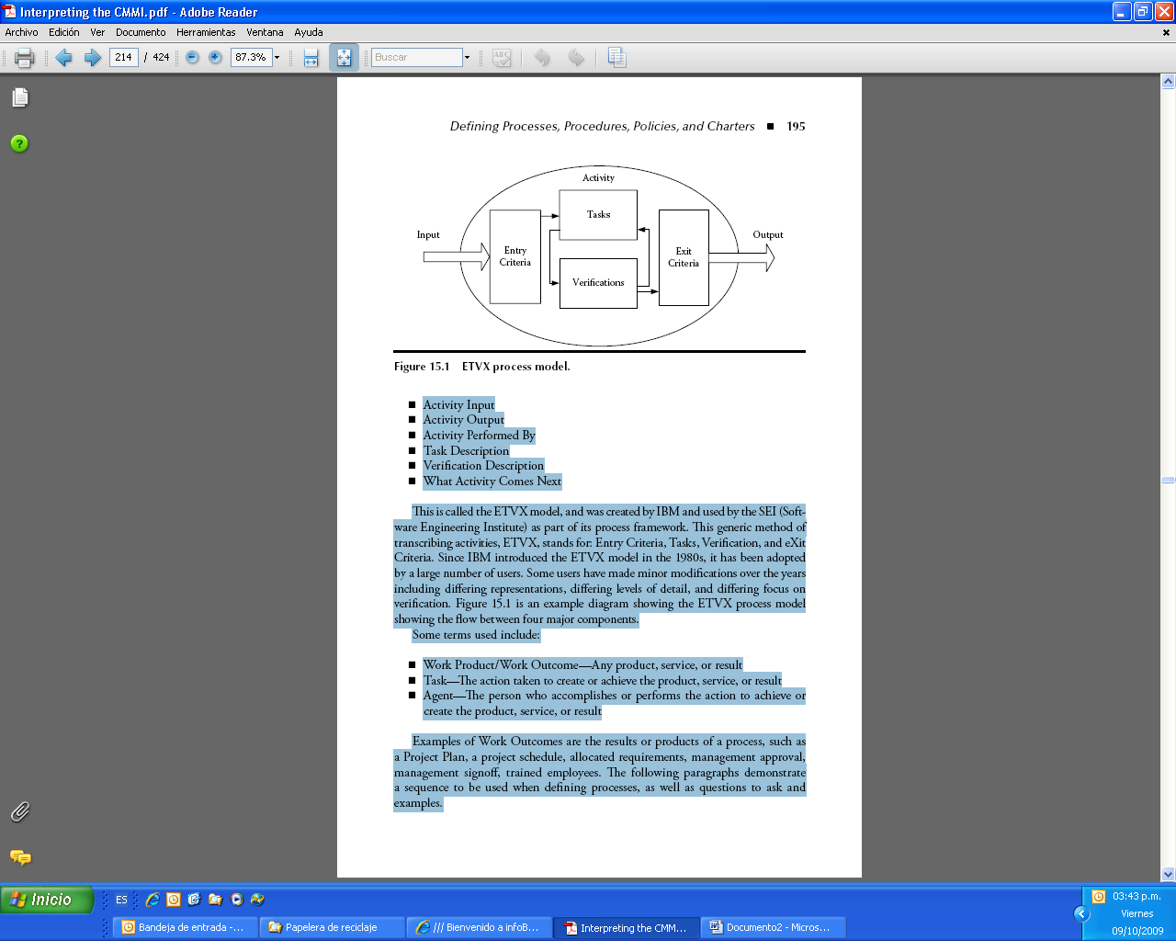

**Table 15.1 Requirements Management Process**

|  |  |
| --- | --- |
| **Action or Task** | **Responsibility** |
| Obtain Work Request from the customer | SM, PM |
| Review Work Request | PM |
| Create Initial Budget/Estimates/Schedule | PM |
| Initial planning | PM, Project team |
| High-level requirements | PM, Project team, customer |
| Risk identification and documentation | PM |
| Requirements Spec DRAFT | PM, Project team |
| Technical review | PM, Project team, QA |
| Customer review | Customer |
| Refine Requirements | PM, Project team, customer |
| Create Requirements Traceability Matrix | PM, Project team |
| Review requirements and RTM | PM, customer, Project team, QA |
| Review/update risks | PM |
| Update estimates and schedules | PM |
| Review requirements and schedule and estimates | PM, Project team, QA, customer |
| Requirements Spec FINAL | PM, analysis |
| Approvals and signoffs | Customer, QA, PM, SM, EPG |
| Baseline Requirements Spec | PM, CCB, EPG |
| Assess track, and incorporate changes | PM, CCB, QA, EPG, Customer, Project team |

LEGEND:

PM = Project Manager

SM = Senior Management

CCB = Configuration Control Board

QA = Quality Assurance

EPG = Engineering Process Group

Table 15.2 Requirements Management (REQM) Process Table of Contents

|  |
| --- |
| 1. INTRODUCTION    1. Purpose    2. Scope    3. Change Management    4. Roles and Responsibilities 2. PROCESS DESCRIPTION    1. Process Overview    2. Process Flow    3. Process Detail       1. Develop the Requirements Specification          1. Description          2. Input/entry criteria          3. Task/activities          4. Conduct review          5. Output/exit criteria       2. Develop the requirements traceability matrix (RTM)          1. Description          2. Input/entry criteria          3. Task          4. Output/exit criteria       3. Changes to Requirements       4. Verification          1. Senior Management Involvement          2. Project Manager (PM) Involment          3. Quality Assurance (QA) Involment          4. Product reviews          5. Management Reviews          6. Customer Reviews 3. RESOURCES AND FUNDING 4. MEASUREMENTS 5. TRAINING 6. REFERENCE DOCUMENTS |

**Table 15.3 Procedure Template**

|  |  |
| --- | --- |
| Document Number | Date  Revision Number |
| Description  This procedure involves … The activity´s primary aim is to …….. | |
| Entry Criteria/Inputs | Exit Criteria / Outputs |
| Roles  Role Name: What does s/ he do? | |
| Assets:  Standards, reference material, deliverables, previous process descriptions ….. |  |
| Summary of tasks ( List major tasks/process steps)  Task 1  Task2  Task3  Task4  PROCEDURE STEPS  TASK1  Detail step 1  Detail step 2  Detail step 3  Detail step4  TASK2  Detail step 1  Detail step 2  Detail step 3  Detail step4  Continue …….. |  |

**Table 15.4 Requirements Management (REQM) Policy**

|  |
| --- |
| 1. **Purpose**   **The purpose of Requirements Management (REQM) is to manage the requirements of the projects products components and to identify inconsistencies between those requirements and the projects plans and work products.**   1. **Scope**   **This policy applies to software projects within the xxx. Division of the xxx organization. The term project, as used in this policy, includes system and software engineering, maintenance, conversion, enhancements, and prorement projects.**   1. **Responsibilities**   **The project manager shall ensure that the REQM process is followed. Each project will follow a process that ensure that requirements will be documented, managed, and traced.**   1. **Verification**   **REQM activities will be reviewed with higher level management, and the process will be objectively evaluated for adherence by the Quality Assurance (QA) staff.**   1. **Signoffs**   **The following shall review and approve this policy.**  **Associate Director**  **Quality Assurance**  **EPG Chairman** |

**Table 15.5 Process Action Team (PAT) Charter Template**

|  |
| --- |
| Customer:  Sponsor:  Start:  Purpose of the PAT:  Linkage to Business Objetives (from strategic or business plan if we have it):  Scope:  Deliverables:  P A T Members:  Name % of Time Role  1  2  3  4  P A T Authority  Assumptions:  Grounds Rules:  Attendance:  Decisions:  Behaviors:  Signoffs: |

**Table 15.6 a Example Engineering Process Group (EPG) Charter.**

|  |
| --- |
| Title: Engineering Process Group Charter  Rev B, March 14, 2007  This document describes the misión, objetives, and preliminary task necessary to establish the Engineering Process Group (EPG) at the xxx organization. This charter will apply to all members of the EPG.  Mission  The misión of the EPG is to implement process improvement (PI) at xxx. PI activities include fostering an understanding of the software Engineering Institute`s (SEI) software Capability Maturity Model Integration (CMMI): conducting baseline SCAMPI; generating in the Action Plans; and monitoring results.  Objetives:  The objetives of PI are to achieve all goals of the Process Areas (Pas) for Level 2 and Level 3.  Level 2 achievement is projected for xxx date. Level 3 achievement is projected for xxx date.  These objetives will be acconmplished by reviewing and augmenting existing documentation; conducting periodic appraisals; performing training and orientation as needed for personnel; participating on teams established to institute PI; incorporating planned activities into existing practices; and monitoring and measuring resilts.  EPG Membership and Operating Procedures  The EPG will consist of senior members of the systems and software development staff, will be managed by the PI Project leader, and will be facilitated by an onsite PI consultant. The EPG will meet once a week. This weekly meeting will serve as a fórum to discuss and resolve issues ocurring during PI Project activities, to introduce information and new technologies or methods into xxx, and to review material generated during Project process improvement activities.  PI Structure  The PI reporting structure is as follows. Each member of the EPG (except for the PI Project leader and PI consultant) will serve as the chaiman (or lead) of each PAT. This structure allows for an effective flow of information from the EPG to each PAT will exist only on a temporary basis.  As the activities detailed in the Action Plan for each PAT are acomplished, that PAT will be disolved. The members of that PAT will then be assingned other PI taks. PAT teams will consist of the EPG representative (as PAT lead) plus other members of the organization, as necessary. For example, if one of the tasks in the Action Plan is to generate Configuration Management standards, a PAT will be established for that purpose. |

**Table 15.6b (continued)**

|  |
| --- |
| Title: Engineering Process Group Charter  Rev B, March 14, 2007  Continued:  The PAT lead may request help in this area from other organizational individuals knowledgeable  In configuration management standars used both at xxx and across the industry. Those individuals may be temporality drafted on a part-time basis to assist in generating those standars.  After the standars have been documented and approved by the EPG, those individuals will no longer be needed, the PAT will be disbanded, and the PAT lead will be used either on another PAT or as needed elsewhere for PI duties.  Steering Committee obligations  The EPG chairman (the PI Project leader) will in turn report EPG activities to management and an Excutive Steering Committee. Senior management determines the budget and is responsable and accountable for the ultímate direction of PI at xxx.  EPG tasks  Initial EPG tasks will include training in the CMMI and the SCAMPI process, generating business meeting rules, setting up PATS, developing detailed Action Plan son a PA by PA basis, and instituting a PI infrastructure.  As result of the SCAMPI presented to management on february 6,2006, the following tasks were generated.  Generate an OSSP to structure further PI efforts.  Search for Standards, where a estándar will provide organizational focus and support, enforced by our QA personnel.  Implement requirements Management (REQM) and Configuration Management (CM) though establishing Pat`s to generate policies, procedures, with the EPG monitoring the results.  Implement a Configuration Control Board (CCB) with the EPG performing this function until resources become available to perfom this function separately from the EPG.  Project Planning (PP) and Project Monitoring and Control (PMC) will be planned and acted upon once the results of the pilots for the preceding Pas (REQM, CM) have been reviewed.  Level2 Pas should be the primary focus at this time. All efforts must be supported by training.  Training must be received, not only in the CMMI, but also in the PA assigned to the various PAT.  Team members PAT Teams cannot be expected to write procedures for performing a PA if they have not been trained in what the CMMI requires and what the PA consists of.  Pilot projects need to be selected to pilot the CMMI procedures and instructions. The monitoring of CMMI-related activities will be performed by the EPG. |